**“Day 1: Laying the foundation for Marketplace”**

**Task for Day 1**

***Step-1: General E-commerce:***

**Clothing E-commerce Website** (template 1)

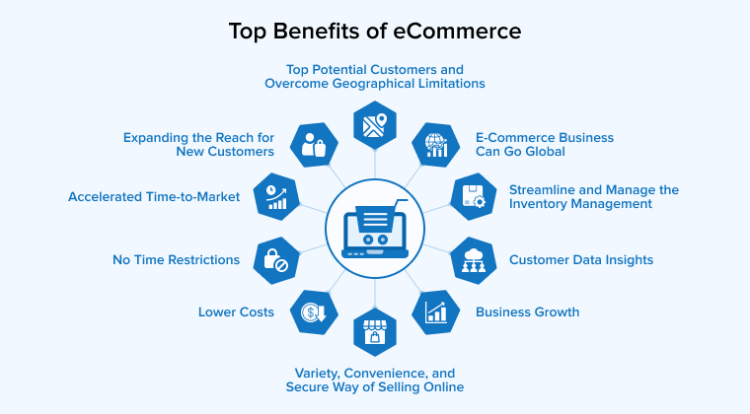

**1. What problem does your marketplace aim to solve?**

This marketplace will provide people to they can buy easily their dream clothes like “Shirt”, “T-shirts”, “Trousers” and so on. In this marketplace people will see their brand clothes and their upcoming new design and too much.

**2. Who is your target audience?**

For those people who are seeking a good online marketplace where they can buy clothes with any hustle and tension. Specifically this marketplace target audience is,

* For young and older Man both can buy clothes from this marketplace.
* Also woman can buy continental and traditional clothes here.
* This marketplace is also best for Kids.

**3. What products or services will you offer?**

Basically we will sell clothes on this online marketplace.

* Shirts, T-shirts and others for Man’s.
* Shirts, T-shirts and others for Woman’s.
* Trousers, Half Trousers, and Shorts for Man and woman.
* All kind of clothes for Toddlers and Kids.

**4. What will set your marketplace apart?**

* Affordable shopping plans.
* Every time people can buy their products.
* Doorstep delivery.
* Safe payment transaction.
* Easy to use for every person.

***Step-3:*** ***Schema Data***

*Schema Data define by an Image below.*

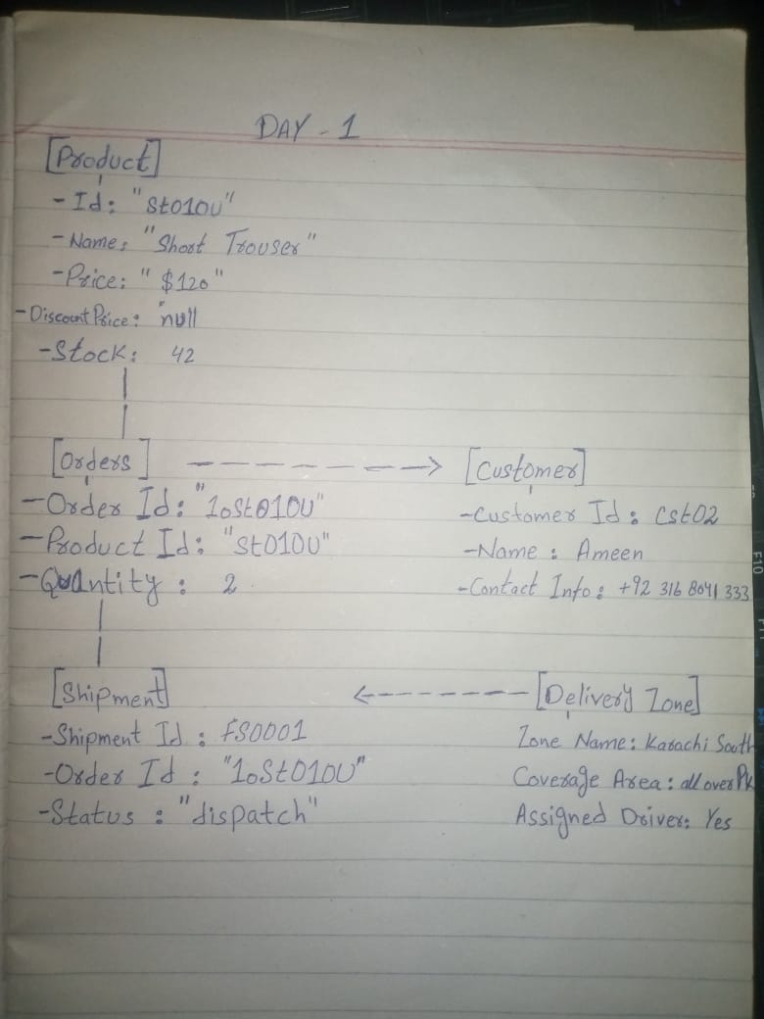

**“Day 2” – Marketplace Technical Foundation**

*This document describe user journey flow for an ecommerce marketplace focusing on key steps and their technical implementation. It is tailored for building a robust and user friendly platform.*

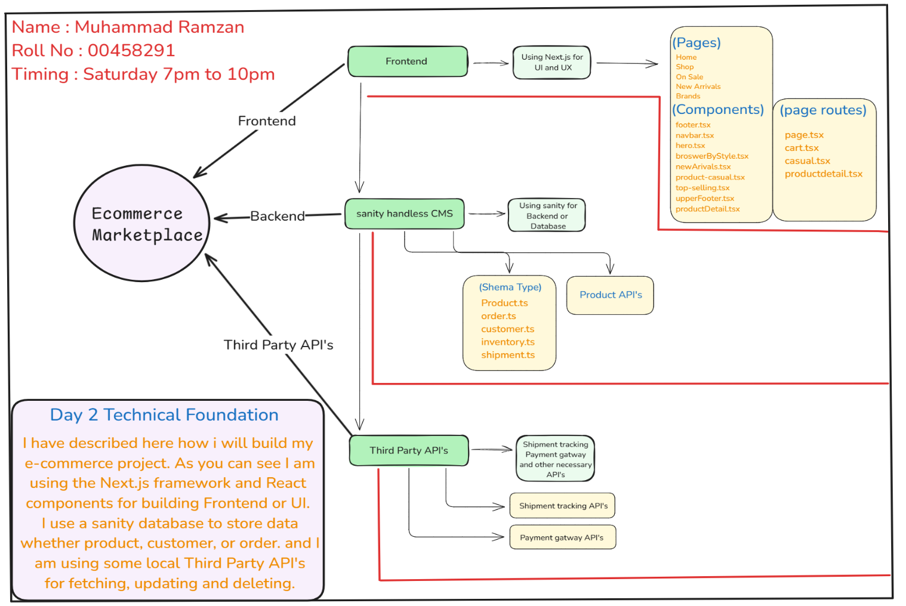

**“Day 3” – API’s integration**

*Document report of “Day 3”.*

* API integration process.
* Adjustments made to schemas.
* Migration steps and tools used.

*Screenshots of:*

* API calling.
* Data successfully displayed in the frontend.
* Populated Sanity CMS fields.
* Code snippets for API integration and migration scripts.

Sanity setup:

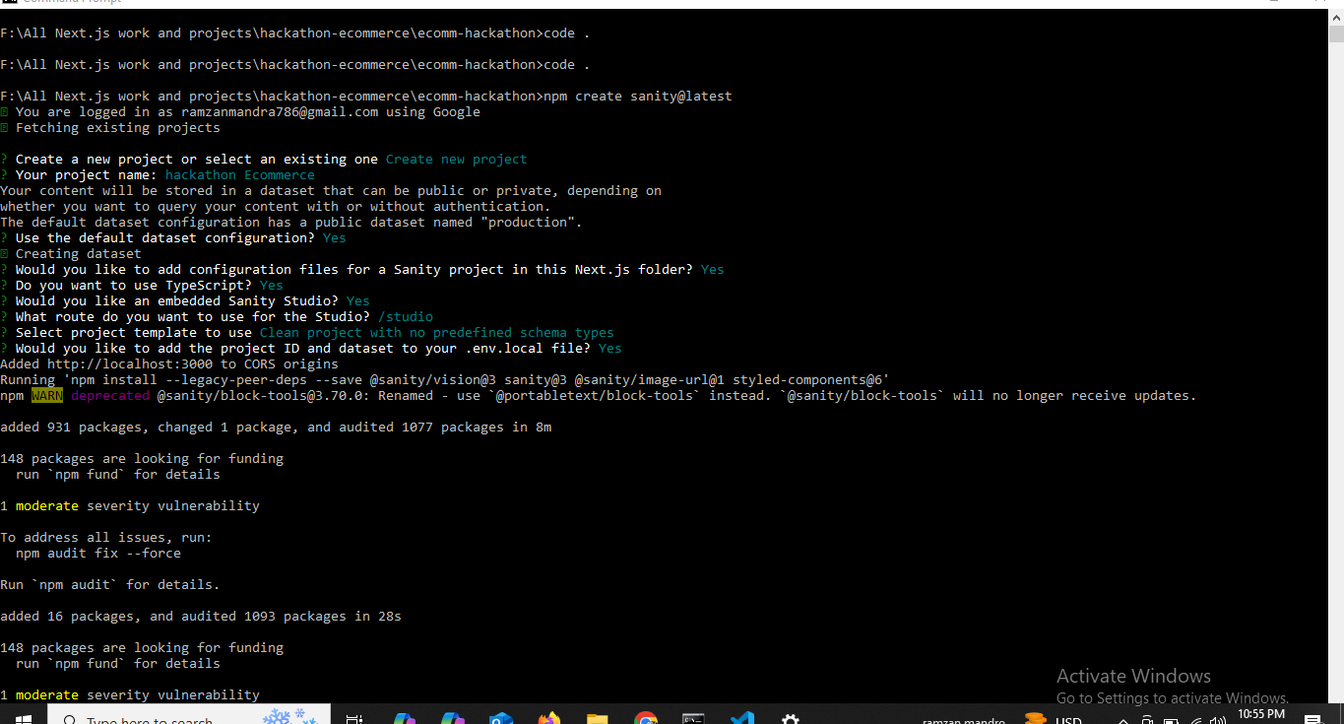

Configuer Project in Sanity:

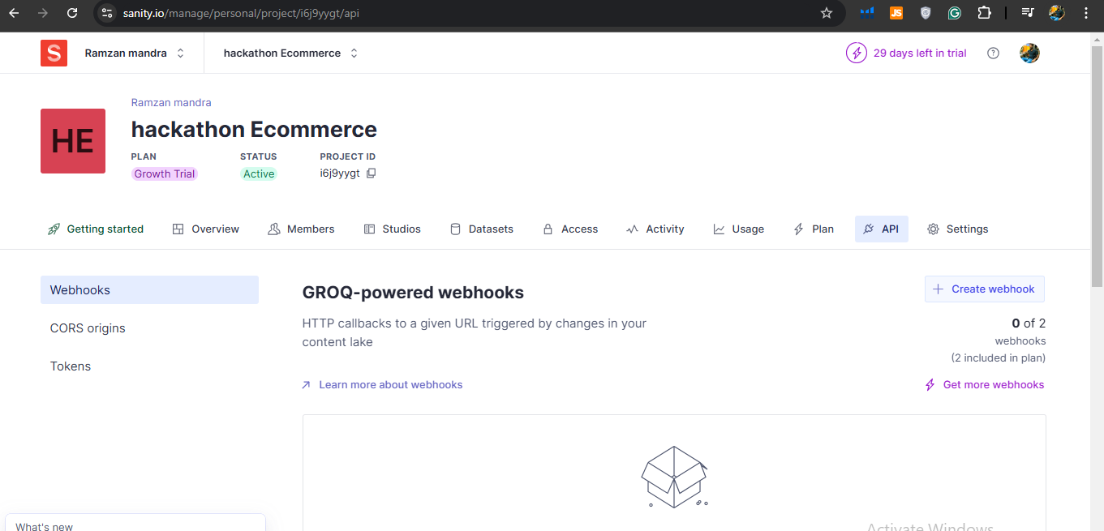

Token screenshot:

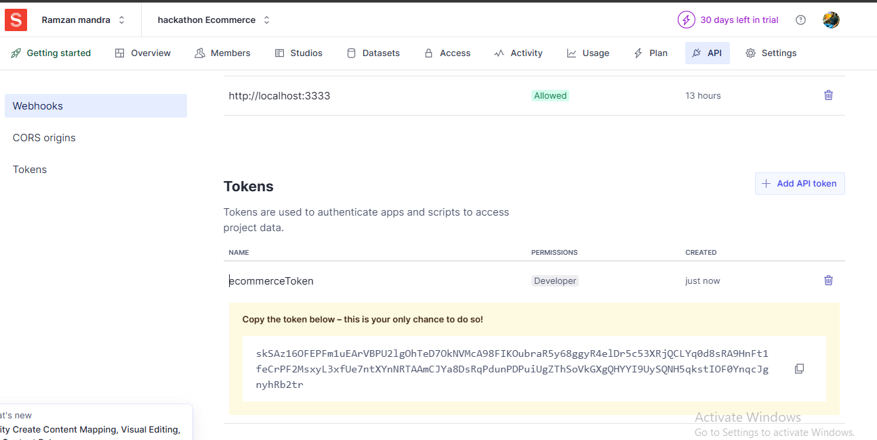

Schema TS file:

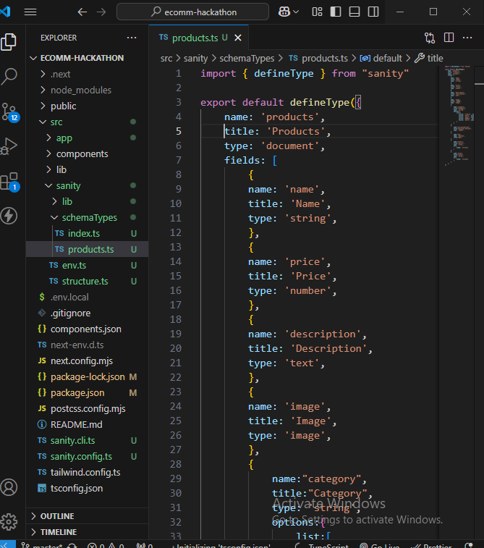

Package.json configuration:

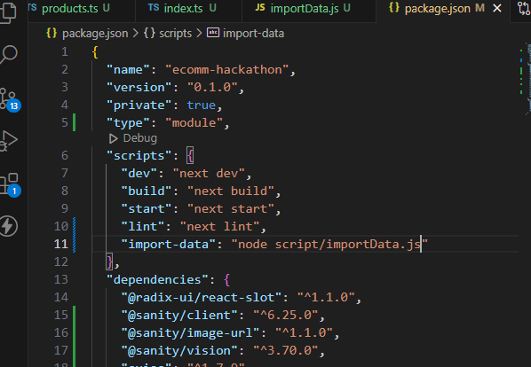

importData.js

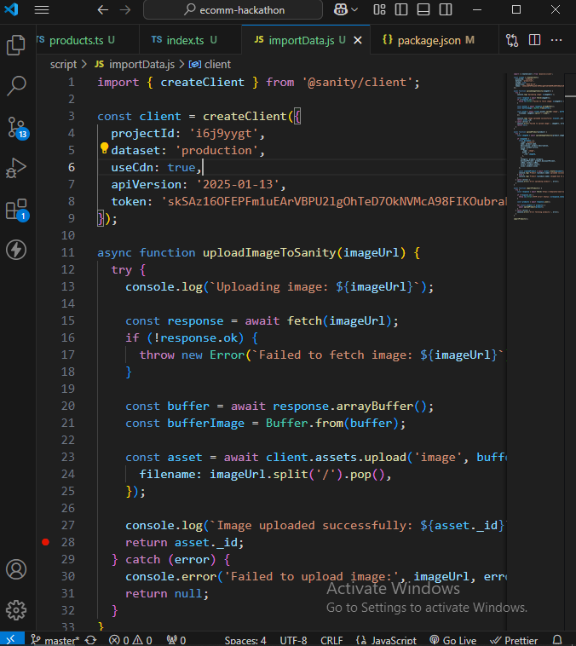

Data Fetching From API and store in Sanity :

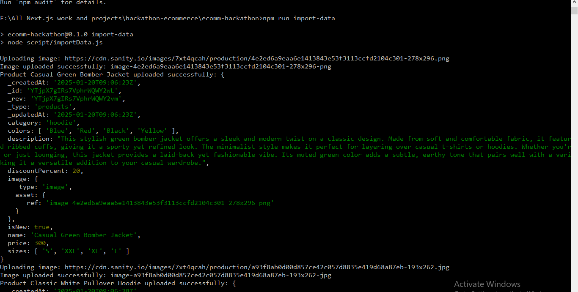

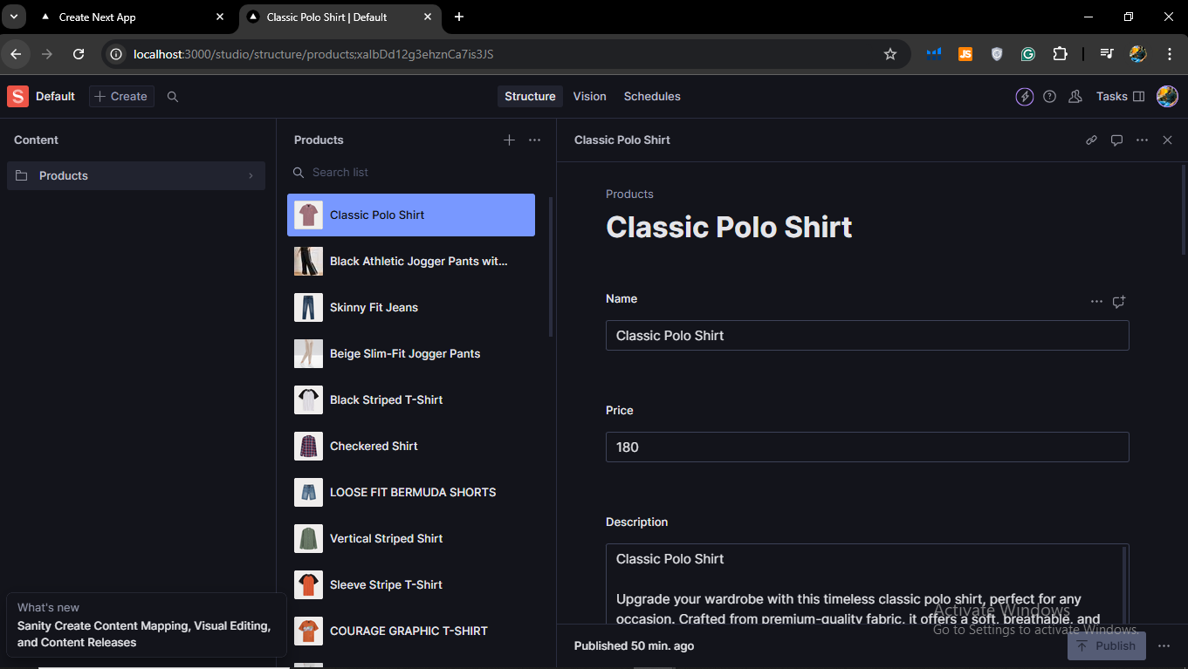

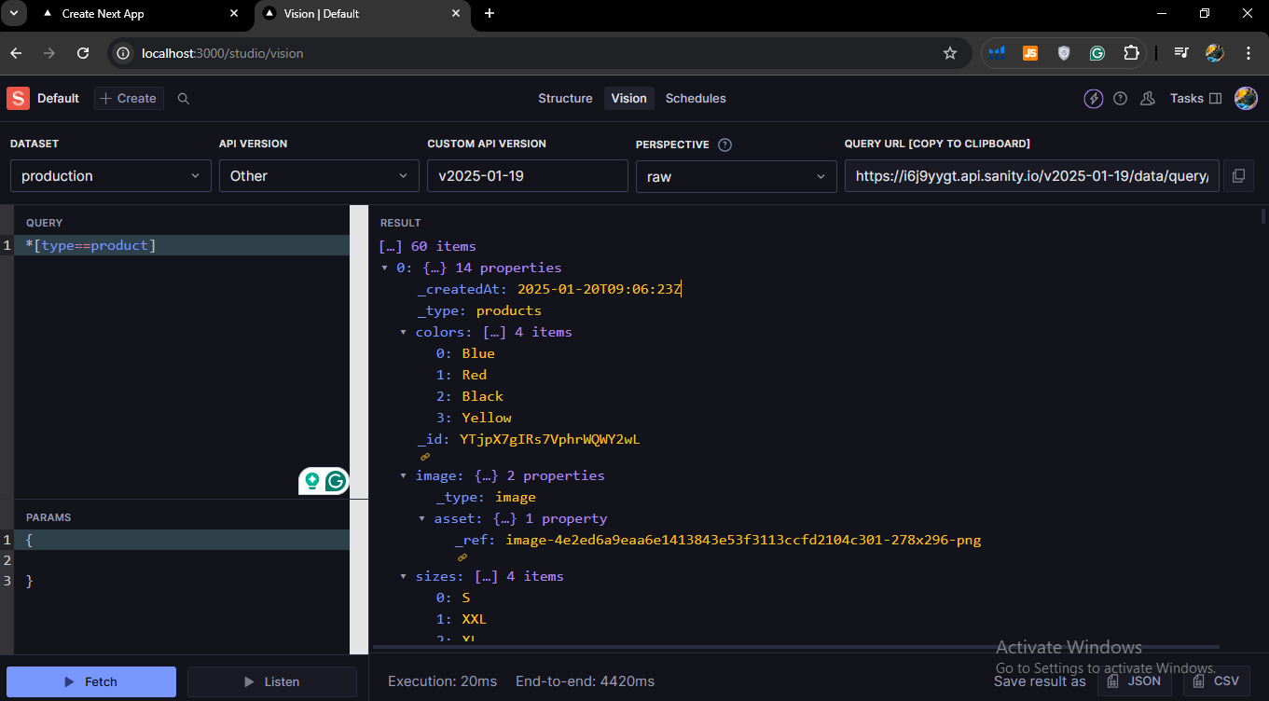

**“Day 4” – Implementation Report**

Introduction:

* SHOP.Co Is the website were buyer can buy clothes globally. This plat form is easy to buy, track and get your product. In this marketplace our try to make sure that no could face any kind of hustle and frustration.

2. Steps Taken to Build and Integrate, components:

* This is my clothing e-commerce project to offer a smooth and stylish shopping experience.
* I have built frontend with Next.js Framework, React components also used in this project like “useStata”, “useEffect” and so on.
* Try to ensures a modern UI I have used Tailwind CSS to design and responsive layout for users across all devices.
* Product fetching shop Page.

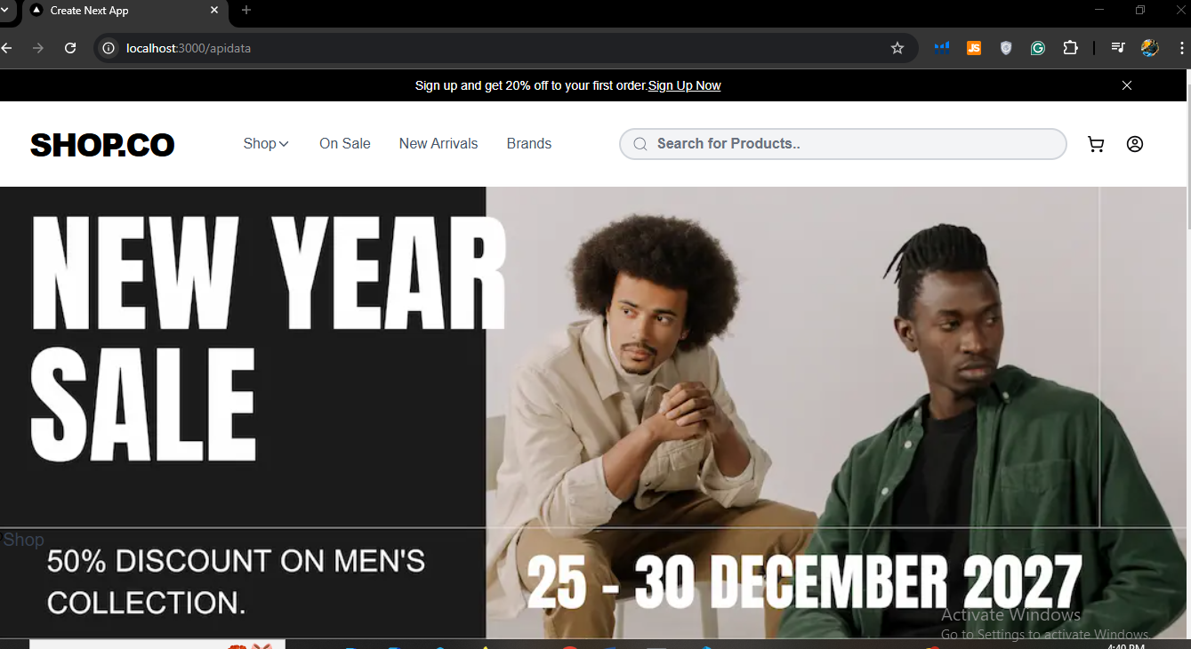

* Here is below two images shows you all products fetching from API which was provided. (template-01)

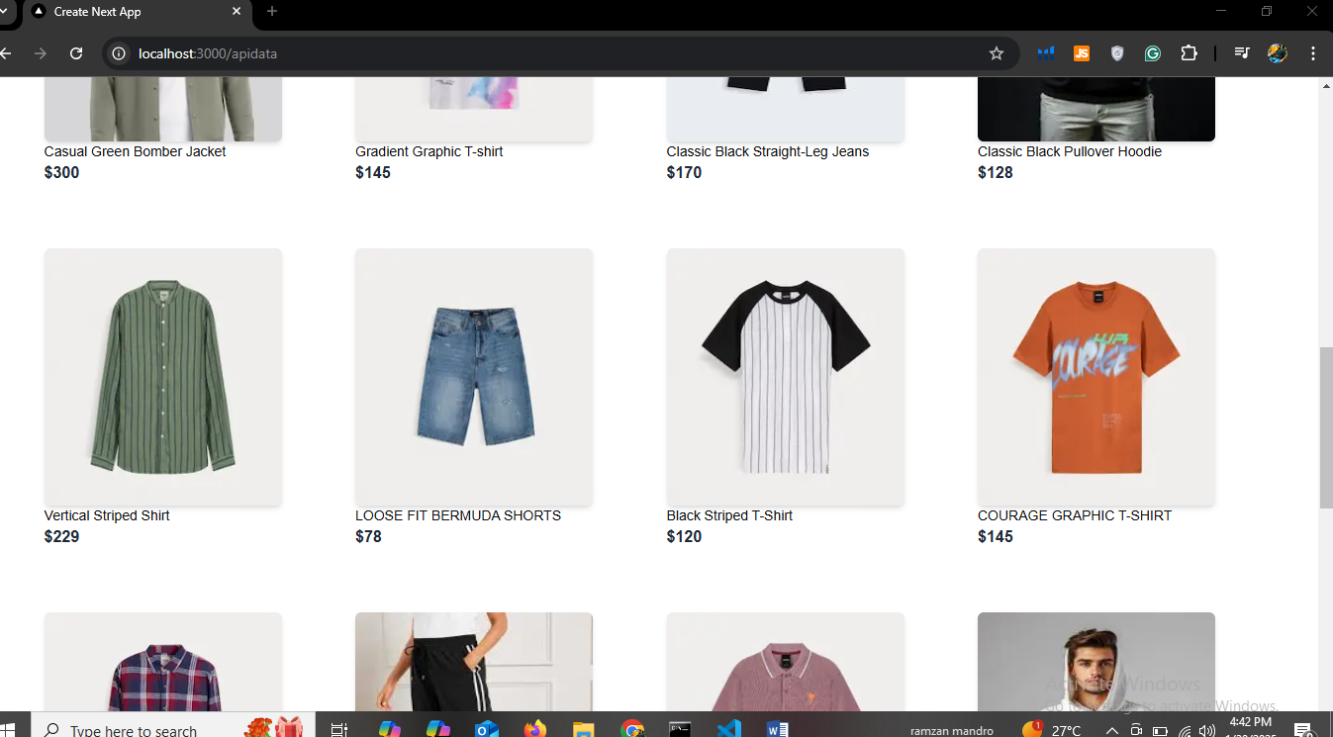

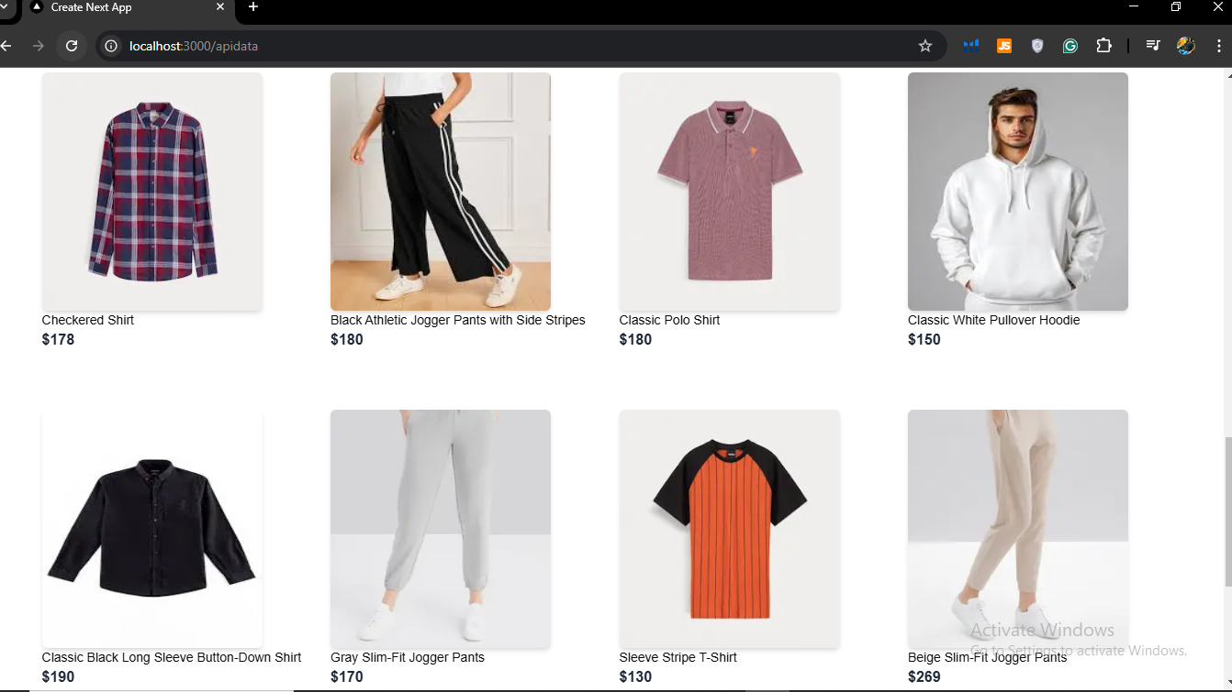

* This Code is belongs to Product Listing Page.

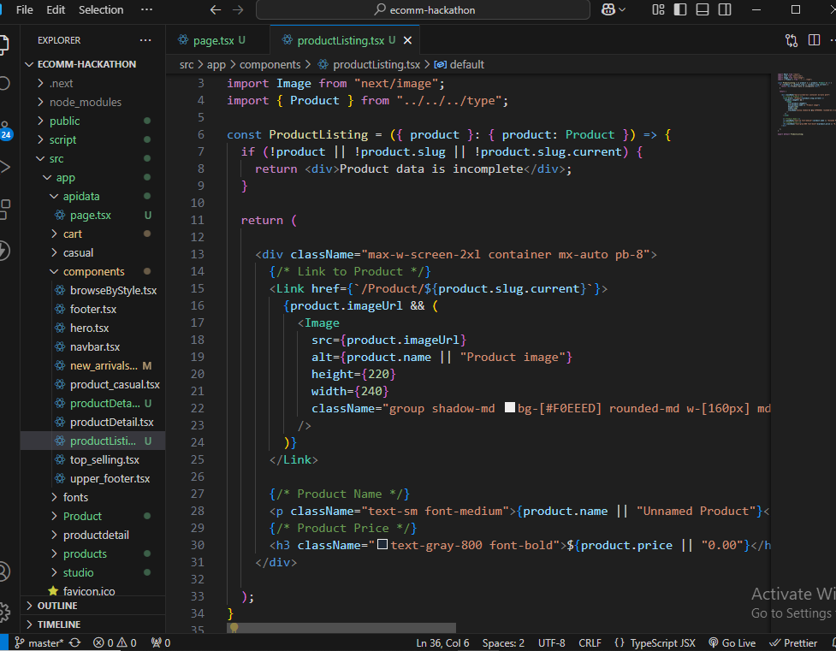

Here below you can see dynamic product pages. ( 3 images )

*Product 1*

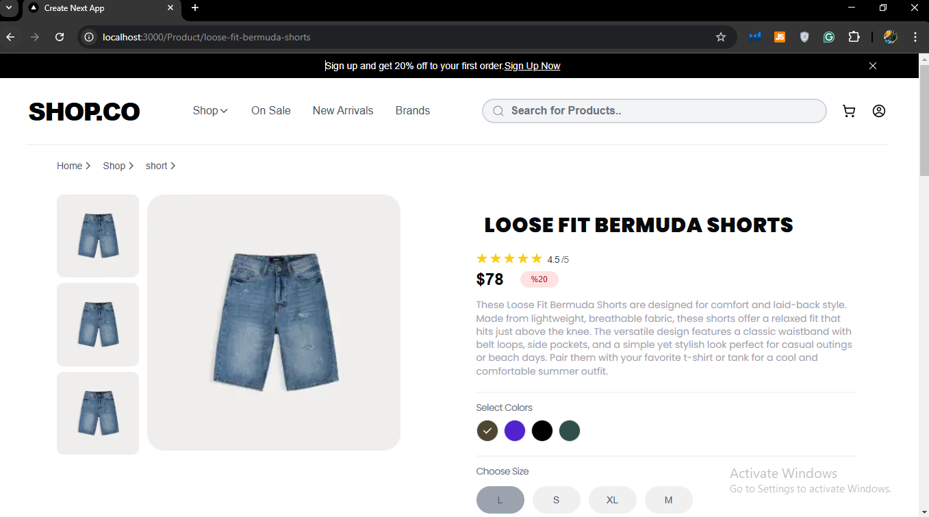

*Product 2*

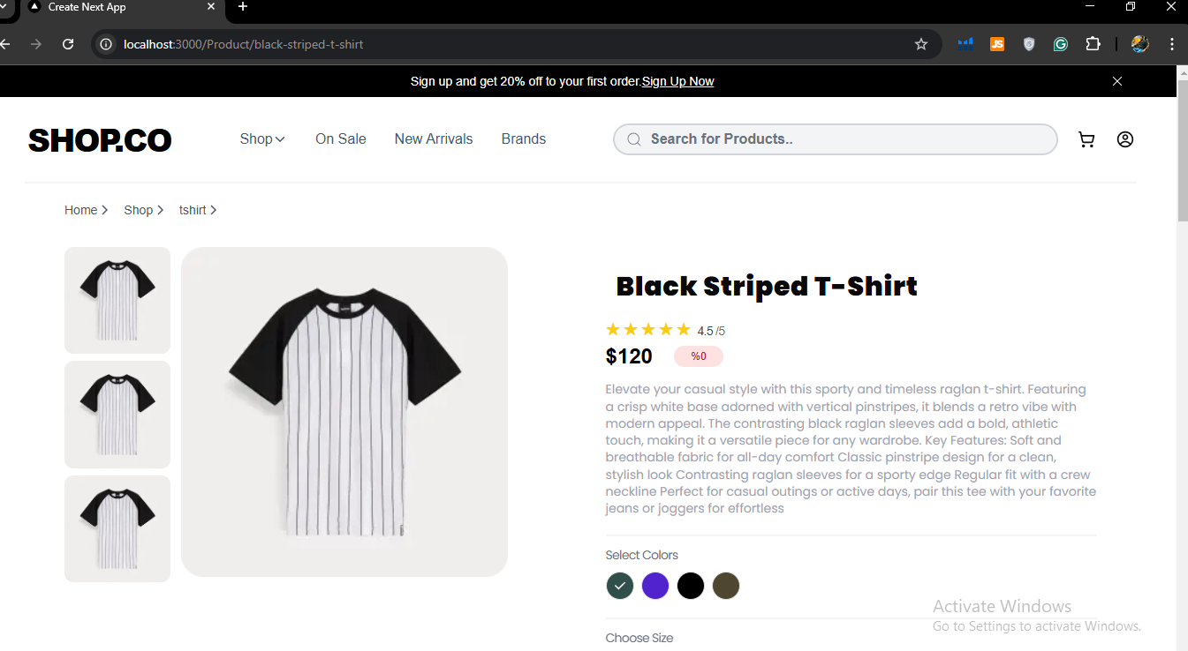

*Product 3*

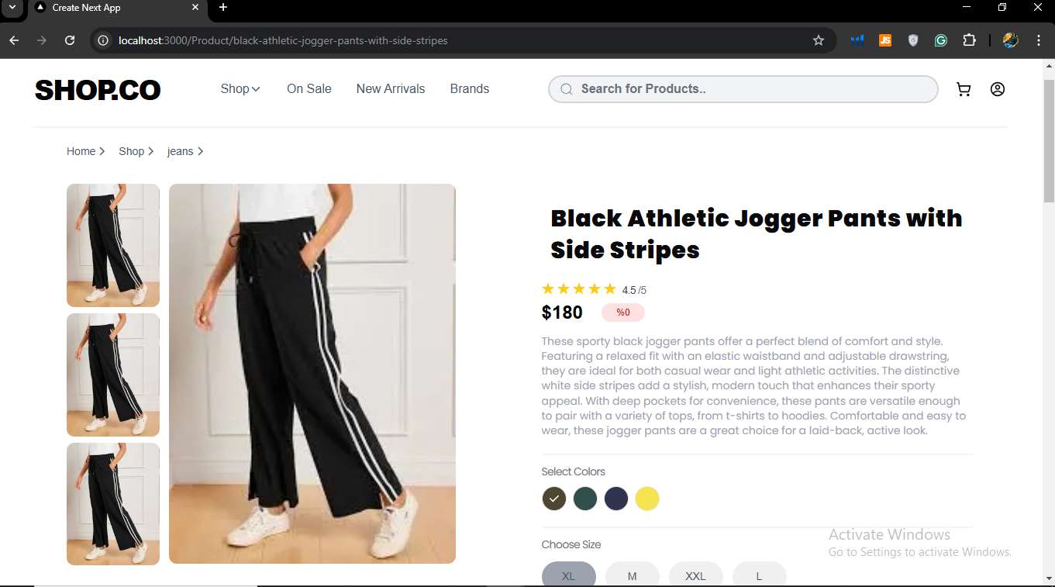

Dynamic product detail page code

Three images

